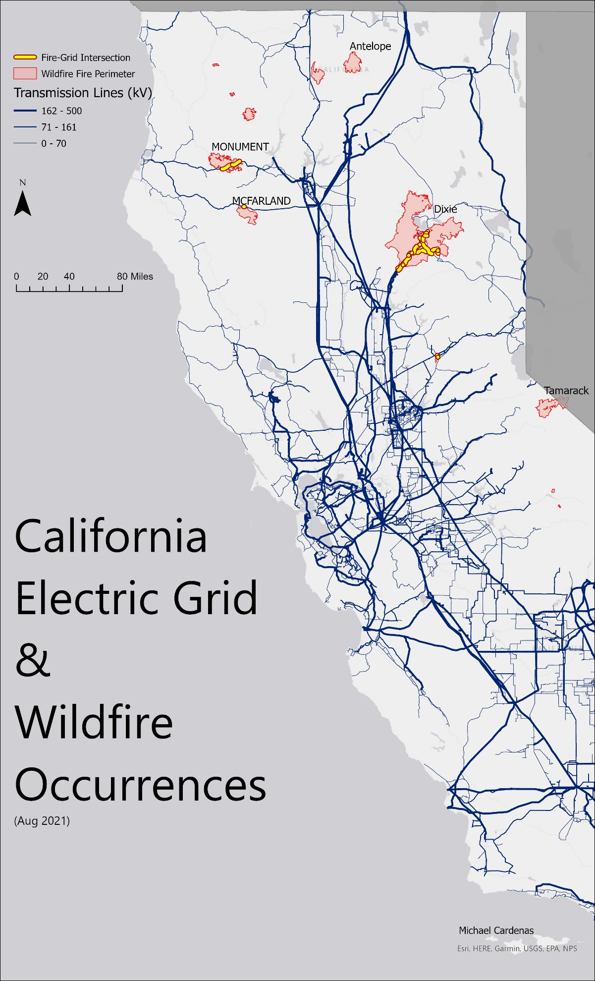This map serves to display the spatial relationship between the California Electric Grid and the occurrences of wildfires in California during the week of August 9, 2021. It does not suggest any causal relationship but simply highlights the areas in which the two layers overlap. The data was readily available from both the California Energy Commission1 and the National Interagency Fire Center2. First, I plotted the distribution of transmission lines throughout California and weighted the thickness of the lines based on their respective kV rating. On top of that, I added the wildfire perimeter polygon layer which shows the current extent to which a fire is burning in a certain area. I added labels as well to denote only the wildfires larger than 35,000 acres. Going back to the main goal of this map, I then highlighted the transmission lines that run through the wildfire areas which happen to include 3 of the bigger wildfires by acreage: Dixie, Monument, and McFarland. For the projection, I decided to stick with the Web Mercator since the area of interest is mostly centered around Northern California and therefore minimal distortion can be found at that scale. 1<https://gis.data.ca.gov/datasets/CAEnergy::california-electric-transmission-lines/about>

2https://www.arcgis.com/home/item.html?id=d957997ccee7408287a963600a77f61f